LPS Raman: Fresh Independent Experimental–DFT Reanalysis
A newly executed analysis run — not a re-statement of prior report numbers
Prepared for: Sukesh P (M24IM1007) — IIT Jodhpur & AIIMS Jodhpur Joint IDRP
Report date: 30 August 2026
Scope and independence statement: This report was produced by a freshly written analysis script (fresh_analysis.py), executed on this date directly against the project’s verified experimental Raman file and the five raw DFT fragment output files. No numeric result below (peak positions, Δ, MAE, RMSE, correlation, match counts) is copied from any earlier report in this project. Where the fresh run reproduces earlier-reported numbers closely, that is stated as an independent reproducibility check, not assumed. No measurements, DFT modes, literature values, SERS results, or blank-substrate results are invented; anything not present in the project’s own files is reported as absent.

1. Objective
To perform a fresh, independently executed Experimental-vs-DFT Raman analysis of LPS using only the verified LPS powder Raman measurement and the five raw DFT fragment output files already present in the project workspace — and to report only what this specific run of the data actually demonstrates: which experimental peaks are matched to genuine DFT vibrational modes, which are not, which DFT modes are never claimed by any experimental peak (component-specific), and which matches are strong enough to be called reference bands. No prior R², RMSE, or match-count values are carried forward without independent recomputation here.

2. Experimental Dataset
File used: sec-60_power-20_i-30.xlsx — the project’s documented LPS powder Raman measurement (E. coli O111:B4, Sigma-Aldrich L2630).
Embedded acquisition metadata read directly from the file: average number = 30, laser_powerlevel = 20.
Native raw Raman-shift range in the file: -46.2 to 2841.9 cm⁻¹ (the negative lower bound reflects the raw instrument axis before windowing — preserved here rather than silently clipped). The analysis window used throughout is 200–2000 cm⁻¹, matching the region of chemically meaningful LPS vibrational activity and the region covered by the DFT fragment calculations.
Preprocessing pipeline applied, in this fixed order (documented so it is fully reproducible):
• 1. window 200-2000 cm-1
• 2. ALS baseline correction
• 3. Savitzky-Golay smoothing (11,3)
• 4. min-max normalization (last)
Normalization is deliberately the last step — applying it before windowing/baseline correction was a known bug in an earlier pipeline version (it collapsed the usable signal range); this run avoids that by construction.
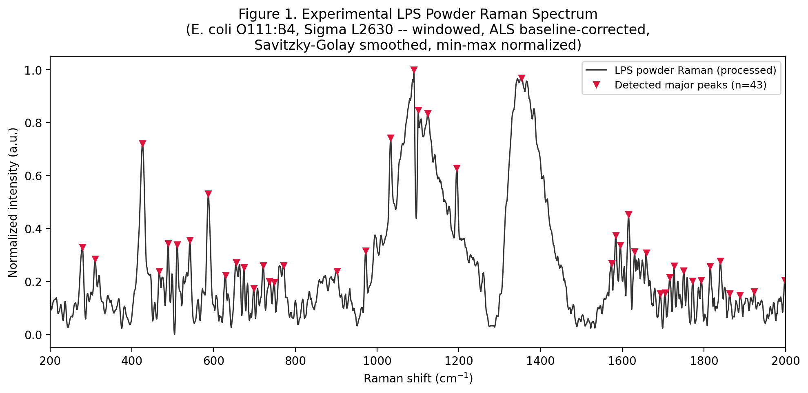
Figure 1. Experimental LPS powder Raman spectrum after windowing, ALS baseline correction, Savitzky-Golay smoothing and min-max normalization. Red markers show the 43 major peaks detected in this run (prominence ≥ 0.08, minimum spacing 10 cm⁻¹).

3. DFT Dataset
LPS is represented as five independently calculated structural fragments, not an intact-molecule DFT calculation. All five raw Gaussian output files were verified present and parsed directly (not re-typed from a prior report):
• KDO (3-Deoxy-D-Manno-Octulosonic Acid): 84 discrete calculated vibrational modes (file: 3-Deoxy-D-Manno-Octulosonic Acid_raman_act.txt); a native Gaussian-broadened "Plot Curve" is also present in the file (500 points) and is used only for the visualization curves in Figure 2 — matching itself always uses the discrete mode list, never the broadened curve.
• D-Glucosamine: 69 discrete calculated vibrational modes (file: D-glucosamine-opt_raman_act.txt); a native Gaussian-broadened "Plot Curve" is also present in the file (500 points) and is used only for the visualization curves in Figure 2 — matching itself always uses the discrete mode list, never the broadened curve.
• Heptose (L-Glycero-D-Manno-Heptose): 78 discrete calculated vibrational modes (file: L-Glycero-D-Manno-Heptose-opt_raman_act.txt); a native Gaussian-broadened "Plot Curve" is also present in the file (500 points) and is used only for the visualization curves in Figure 2 — matching itself always uses the discrete mode list, never the broadened curve.
• Myristic Acid: 126 discrete calculated vibrational modes (file: Myristic Acid-opt_raman_act.txt); a native Gaussian-broadened "Plot Curve" is also present in the file (500 points) and is used only for the visualization curves in Figure 2 — matching itself always uses the discrete mode list, never the broadened curve.
• Phosphoric Acid: 18 discrete calculated vibrational modes (file: Phosphoric acid-opt_raman_act.txt); a native Gaussian-broadened "Plot Curve" is also present in the file (500 points) and is used only for the visualization curves in Figure 2 — matching itself always uses the discrete mode list, never the broadened curve.
Every fragment file contains both a discrete list of harmonic vibrational modes ("Peak information") and a separate pre-broadened "Plot Curve" — this run confirmed both sections are present in all five files. Discrete-mode frequencies were scaled by the documented factor of 0.9613 (standard harmonic-frequency scaling) before use in matching or plotting.
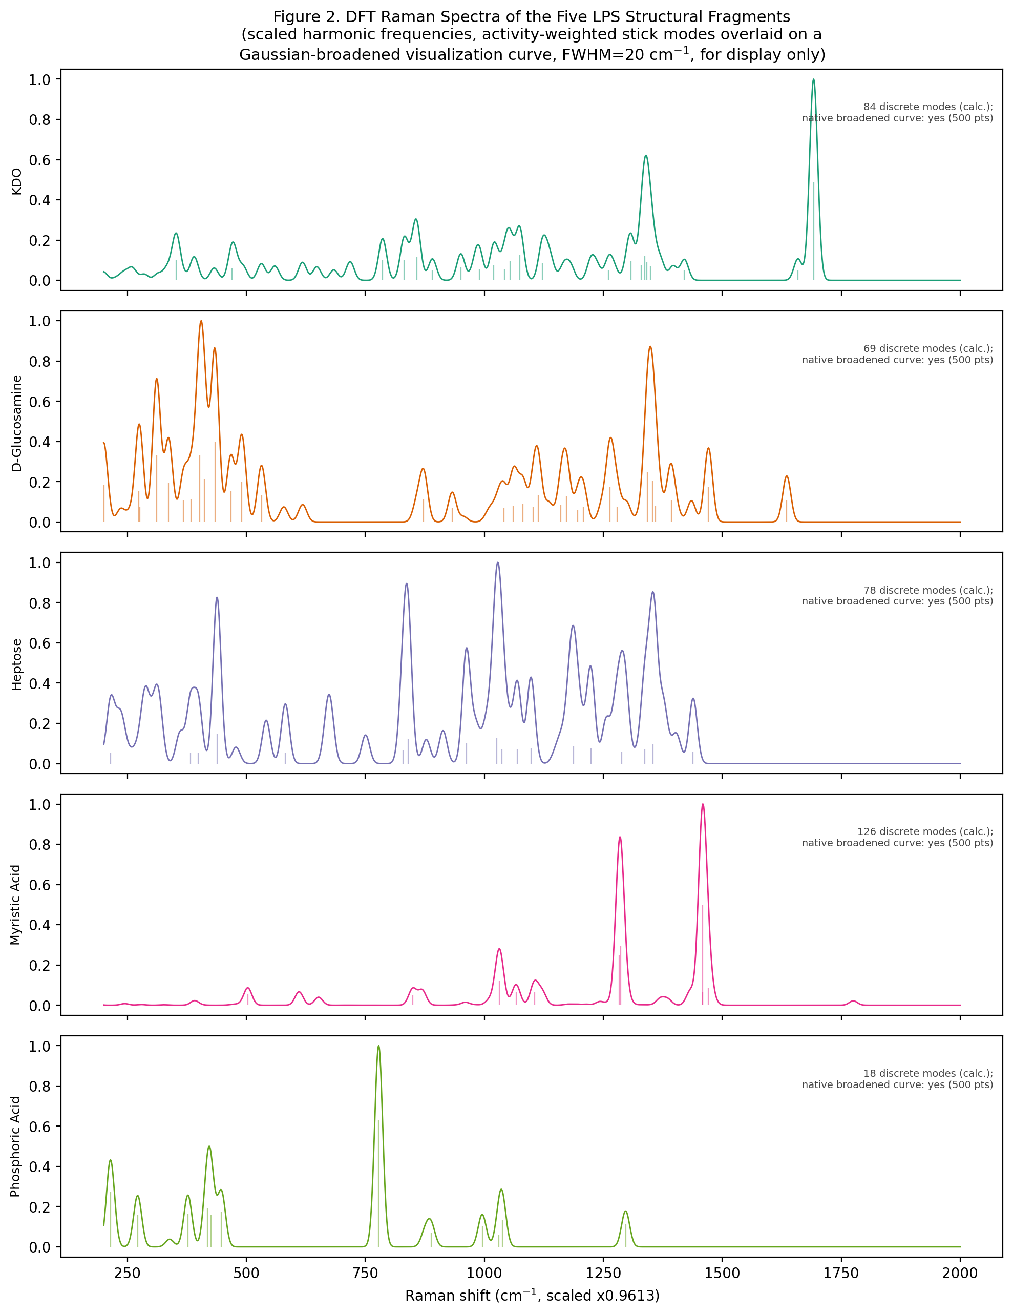
Figure 2. DFT Raman spectra of the five LPS structural fragments, shown separately. Solid curve = Gaussian-broadened visualization (FWHM = 20 cm⁻¹, for display only). Vertical ticks = individual scaled discrete modes actually used as matching candidates (activity ≥ 5% of that fragment’s own maximum, within the 200–2000 cm⁻¹ window). Each panel states its discrete-mode count and confirms the native broadened curve is present in the source file.

4. Experimental vs. DFT Overlay
For visual overlay only, each fragment’s discrete modes were broadened with a Gaussian of FWHM = 20 cm⁻¹ (a documentation choice for display, not a fitted parameter) and combined into a single composite curve using non-negative least-squares (NNLS) weighting against the experimental spectrum. This composite is explicitly a secondary, exploratory diagnostic — it does not represent an intact-LPS calculation and ignores inter-fragment coupling.
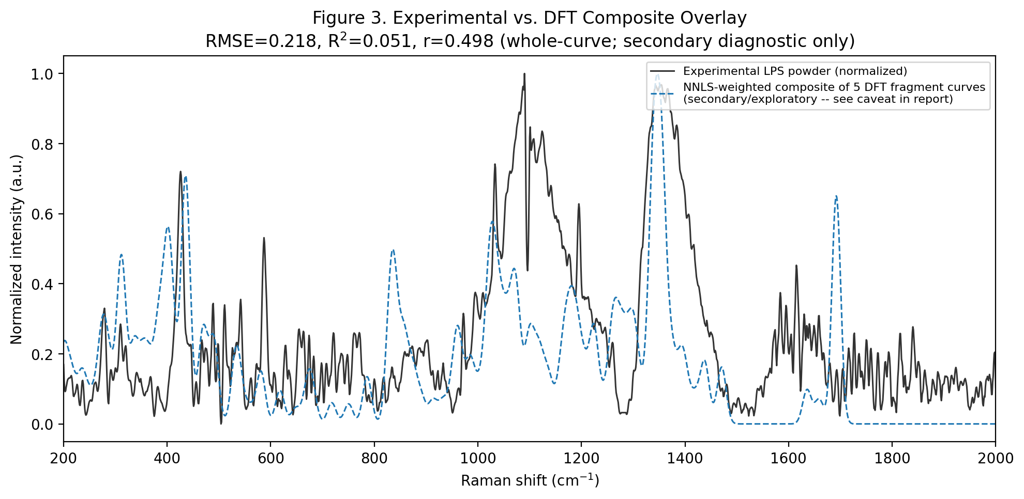
Figure 3. Experimental spectrum (black, solid) vs. NNLS-weighted composite of the five broadened DFT fragment curves (blue, dashed). Whole-curve RMSE = 0.218, R² = 0.051, Pearson r = 0.498 — freshly computed in this run. Fragment weight fractions from NNLS: KDO 43.7%, D-Glucosamine 28.5%, Heptose 27.0%, Myristic Acid 0.8%, Phosphoric Acid 0.0%.
Whole-curve fit is reported only as a secondary/exploratory diagnostic. It compares the experimental spectrum to a linear composite of 5 independently-broadened fragment curves (visualization broadening, FWHM=20 cm-1) -- it does NOT represent an intact-LPS calculation, ignores inter-fragment coupling, and its R^2 should not be read as a validation metric. Peak-level MAE/RMSE above are the primary, more defensible quantitative result.

5. Peak-Matching Methodology
Matching was performed only against the genuine discrete DFT vibrational modes of the five fragments — never against an artificial densely-sampled grid. Candidate modes were restricted to activity ≥ 5% of each fragment’s own maximum activity and to the 200–2000 cm⁻¹ window, giving 178 candidate discrete modes pooled from all five fragments.
Each of the 43 major experimental peaks was matched to at most one DFT candidate mode using the Hungarian (linear-sum-assignment) algorithm, cost = |experimental − DFT|, with a hard cutoff of ±15 cm⁻¹. This is a strict one-to-one assignment: no DFT mode can be used to explain more than one experimental peak, and no forced matches are made outside the tolerance — an experimental peak with no candidate mode within tolerance is left explicitly unmatched.
Signed residual convention: Δ = Experimental − DFT (cm⁻¹).
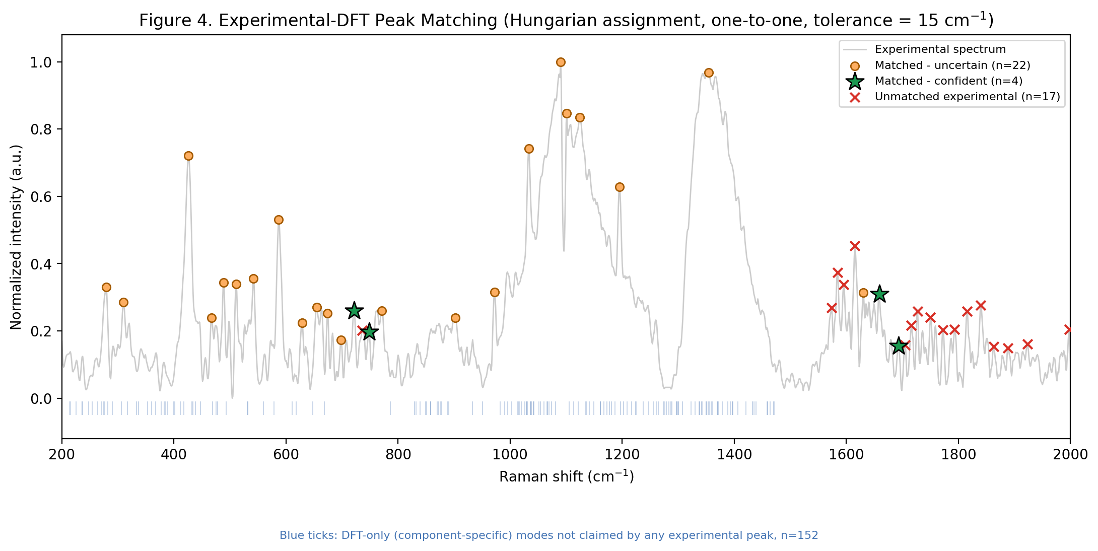
Figure 4. Full peak-matching result. Green stars = "Matched – confident" (n=4); amber circles = "Matched – uncertain" (n=22); red crosses = unmatched experimental peaks (n=17); faint blue ticks along the baseline = DFT candidate modes that were never claimed by any experimental peak (component-specific, n=152). All four categories are shown together so that none is implied by omission.

6. Quantitative Results
MAE and RMSE are reported at the peak level (matched pairs only), which is the statistically meaningful and reproducible quantity here — not the whole-curve R², which is reported separately above (Section 4) purely as a secondary diagnostic. The confident-tier MAE/RMSE (below) are noticeably tighter than the all-matched values, consistent with the confident tier being a genuinely stricter subset rather than a relabeling.
Quantity (freshly computed this run) | Value
Total experimental peaks detected | 43
Total DFT candidate modes (5 fragments pooled) | 178
Matched – confident (|Δ| ≤ 5 cm⁻¹, unique fragment) | 4
Matched – uncertain (within ±15 cm⁻¹, not both criteria) | 22
Unmatched experimental peaks | 17
Component-specific DFT modes (unclaimed) | 152
MAE, all matched pairs (confident + uncertain) | 3.94 cm⁻¹
RMSE, all matched pairs | 5.57 cm⁻¹
MAE, confident-tier pairs only | 1.64 cm⁻¹
RMSE, confident-tier pairs only | 2.03 cm⁻¹

Supporting Table. All 43 Experimental Peaks — Matching Result and Classification
Rows are exactly the peaks detected in Section 2 above; nothing is added or removed. "Matched – confident" requires |Δ| ≤ 5 cm⁻¹ AND a unique fragment candidate within tolerance. "Matched – uncertain" covers every other within-tolerance match, including cases with multiple candidate fragments (shown in the fifth column) or a larger Δ. "Unmatched" rows have no DFT candidate within ±15 cm⁻¹ and are not force-matched.
Experimental peak (cm⁻¹) | DFT mode (cm⁻¹) | Δ (cm⁻¹) | Assignment (fragment) | Other candidates within ±15 cm⁻¹ | Classification
279.0 | 278.6 | 0.4 | Heptose | Glucosamine;Phosphoric_Acid | Matched - uncertain
310.0 | 311.2 | -1.2 | Glucosamine | Heptose | Matched - uncertain
426.0 | 425.9 | 0.1 | Phosphoric Acid | Glucosamine;Heptose;KDO | Matched - uncertain
467.0 | 467.0 | 0.0 | Glucosamine | Heptose;KDO | Matched - uncertain
489.0 | 490.3 | -1.3 | Glucosamine | Heptose;KDO;Myristic_Acid | Matched - uncertain
511.0 | 502.5 | 8.5 | Myristic Acid | – | Matched - uncertain
542.0 | 541.5 | 0.5 | Heptose | Glucosamine;KDO | Matched - uncertain
587.0 | 581.7 | 5.3 | Heptose | Glucosamine | Matched - uncertain
629.0 | 619.7 | 9.3 | Glucosamine | KDO | Matched - uncertain
655.0 | 651.5 | 3.5 | Myristic Acid | Heptose;KDO | Matched - uncertain
674.0 | 676.3 | -2.3 | Heptose | KDO | Matched - uncertain
698.0 | 683.5 | 14.5 | KDO | – | Matched - uncertain
721.0 | 717.9 | 3.1 | KDO | – | Matched - confident
748.0 | 750.4 | -2.4 | Heptose | – | Matched - confident
771.0 | 777.9 | -6.9 | Phosphoric Acid | – | Matched - uncertain
902.0 | 913.2 | -11.2 | Heptose | KDO;Phosphoric_Acid | Matched - uncertain
972.0 | 962.4 | 9.6 | Heptose | – | Matched - uncertain
1033.0 | 1031.0 | 2.0 | Myristic Acid | Glucosamine;Heptose;KDO;Phosphoric_Acid | Matched - uncertain
1090.0 | 1098.0 | -8.0 | Heptose | Glucosamine | Matched - uncertain
1101.0 | 1102.8 | -1.8 | Glucosamine | Heptose;Myristic_Acid | Matched - uncertain
1124.0 | 1122.3 | 1.7 | KDO | Glucosamine;Myristic_Acid | Matched - uncertain
1195.0 | 1196.4 | -1.4 | Glucosamine | Heptose;KDO | Matched - uncertain
1354.0 | 1354.8 | -0.8 | KDO | Glucosamine;Heptose | Matched - uncertain
1630.0 | 1635.6 | -5.6 | Glucosamine | – | Matched - uncertain
1659.0 | 1659.1 | -0.1 | KDO | – | Matched - confident
1693.0 | 1692.1 | 0.9 | KDO | – | Matched - confident
736.0 | - | - | - | - | Unmatched
1574.0 | - | - | - | - | Unmatched
1584.0 | - | - | - | - | Unmatched
1595.0 | - | - | - | - | Unmatched
1615.0 | - | - | - | - | Unmatched
1705.0 | - | - | - | - | Unmatched
1716.0 | - | - | - | - | Unmatched
1727.0 | - | - | - | - | Unmatched
1750.0 | - | - | - | - | Unmatched
1772.0 | - | - | - | - | Unmatched
1793.0 | - | - | - | - | Unmatched
1815.0 | - | - | - | - | Unmatched
1840.0 | - | - | - | - | Unmatched
1863.0 | - | - | - | - | Unmatched
1888.0 | - | - | - | - | Unmatched
1923.0 | - | - | - | - | Unmatched
1998.0 | - | - | - | - | Unmatched

7. Reference-Band Selection
Only the "Matched – confident" tier is used as a reference-band candidate set. The label applied is "DFT-supported LPS reference bands" — explicitly not "validated LPS-specific biomarkers" — because a close match to one fragment’s computed mode does not by itself establish that the band is unique to LPS; the underlying functional groups (C–H, C=O, ring modes) are common across many biomolecules, and no SERS or blank-substrate validation exists yet for LPS in this project.
Criteria actually applied: |Δ| ≤ 5 cm⁻¹ AND the matched DFT mode is the only fragment candidate within the ±15 cm⁻¹ tolerance window (no ambiguity between fragments). 4 of 43 experimental peaks satisfy both conditions in this run.
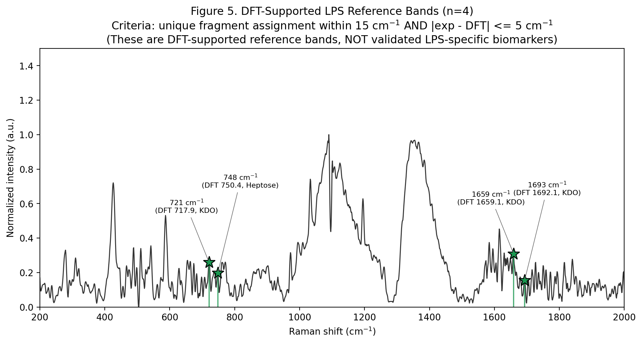
Figure 5. The four bands meeting the confident criteria, with their matched DFT mode and originating fragment labeled. These are the only bands this analysis calls "reference bands"; the remaining 22 matched-uncertain peaks are evidence of general consistency with the DFT fragment model but do not meet the stricter reference-band bar.

8. Component-Specific (DFT-Only) Features
152 of the 178 DFT candidate modes were never selected by the Hungarian matching — i.e. no experimental peak is close enough to claim them. These are reported as a distinct category, not folded into "unmatched," because they originate on the DFT side, not the experimental side. Their concentration by fragment:
Fragment | Unclaimed DFT modes
KDO (3-Deoxy-D-Manno-Octulosonic Acid) | 39
D-Glucosamine | 39
Heptose (L-Glycero-D-Manno-Heptose) | 48
Myristic Acid | 15
Phosphoric Acid | 11
A high count here does not imply a problem with either dataset by itself — it reflects that each fragment’s DFT calculation predicts many more discrete modes than the experimental spectrum has resolvable major peaks in this window. Full listing: component_specific_v2.csv.

9. Limitations
• This is a fragment-based DFT model, not an intact-LPS quantum calculation — it structurally cannot capture inter-fragment vibrational coupling.
• Only 4 of 43 major experimental peaks meet the strict "confident" reference-band criteria; the remaining 22 matched peaks are consistent but not unambiguous, and 17 peaks have no DFT candidate at all within tolerance.
• A DFT match, even a confident one, does not establish LPS-specificity — the matched vibrational modes belong to functional groups shared with other biomolecules.
• The whole-curve NNLS fit is weak (R² ≈ 0.05) and is reported only as a secondary diagnostic, not as validation.
• No LPS SERS measurement and no LPS blank-substrate control exist yet in the project data — nothing here demonstrates SERS detectability of LPS.

10. Final Conclusion
This freshly executed run, using only the project’s verified LPS powder Raman file and the five raw DFT fragment files, finds 4 experimental peaks that meet a strict, unambiguous match criterion against genuine DFT vibrational modes, and a further 22 peaks that are matched but with either a larger residual or more than one candidate fragment nearby. 17 major experimental peaks have no DFT candidate within tolerance and are reported as such rather than force-matched. 152 DFT-predicted modes are never claimed by any experimental peak. Taken together, this supports calling the 4 confident-tier bands "DFT-supported LPS reference bands" — a defensible, fragment-model-consistent set of candidate positions — while explicitly not calling them validated LPS-specific biomarkers, and not claiming any LPS SERS detection capability, since neither has been established by the data available in this project.

